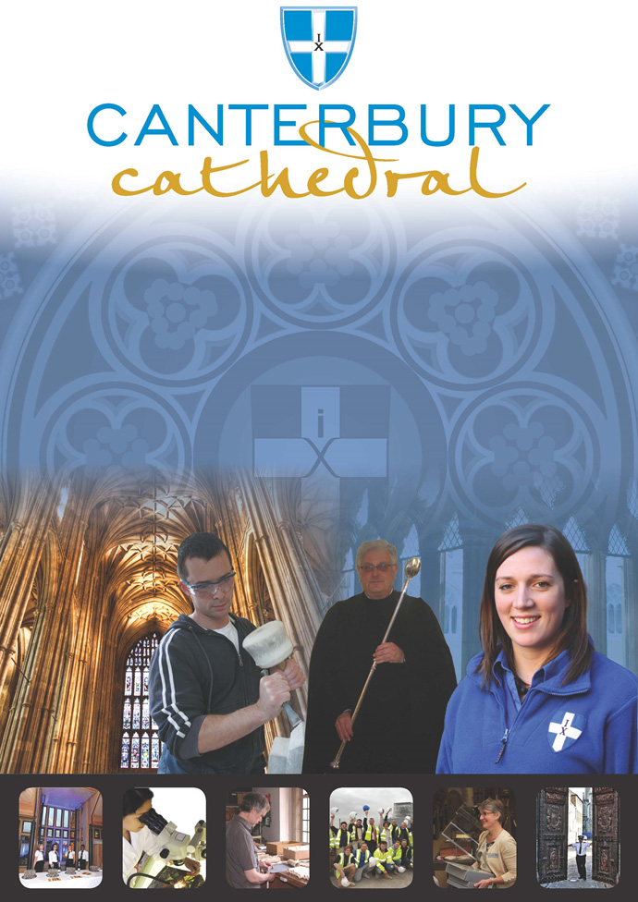

PROFILE OF CANTERBURY CATHEDRAL
St Augustine, the first Archbishop of Canterbury, arrived on the coast of Kent as a missionary to England in 597 AD. He came from Rome, sent by Pope Gregory the Great. It is said that Gregory had been struck by the beauty of Angle slaves he saw for sale in the city market and dispatched Augustine and some monks to convert them to Christianity. Augustine was given a church at Canterbury (St Martin’s, after St Martin of Tours, still standing today) by the local King, Ethelbert whose Queen, Bertha, a French Princess, was already a Christian. This building had been a place of worship during the Roman occupation of Britain and is the oldest church in England still in use. Augustine had been consecrated a bishop in France and was later made an archbishop by the Pope. He established his seat within the Roman city walls (the word cathedral is derived from the Latin word for a chair ‘cathedra’, which is itself taken from the Greek ‘kathedra’ meaning seat.) and built the first cathedral there, becoming the first Archbishop of Canterbury. Since that time, there has been a community around the Cathedral offering daily prayer to God; this community is arguably the oldest organisation in the English speaking world. The present Archbishop, The Most Revd Justin Welby, is 105th in the line of succession from Augustine.
Augustine’s original building lies beneath the floor of the nave– it was extensively rebuilt and enlarged by the Saxons, and the Cathedral was rebuilt completely by the Normans in 1070 following a major fire. There have been many additions to the building over the last nine hundred years, but parts of the quire and some of the windows and their stained glass date from the 12th century.
By 1077, Archbishop Lanfranc had rebuilt it as a Norman church, described as “nearly perfect”. A staircase and parts of the North Wall – in the area of the North West transept also called the Martyrdom – remain from that building.
During the Second World War, the Precincts were heavily damaged by enemy action and the Cathedral’s Library was destroyed. Thankfully, the Cathedral itself was not seriously harmed, due to the bravery of the team of fire watchers, who patrolled the roofs and dealt with the incendiary bombs dropped by enemy bombers.
Today, the Cathedral stands as a place where prayer to God has been offered daily for over 1,400 years; nearly 2,000 services are held each year, as well as countless private prayers from individuals. The Cathedral offers a warm welcome to all visitors – its aim is to show people Jesus, which we do through the splendour of the building as well as the beauty of the worship.

THE WORK OF THE CATHEDRAL
The work of the Cathedral is carried out by over 300 paid staff, supported by some 500 volunteers. The ‘corporate body’ responsible for the management of the Cathedral is the Chapter of Canterbury who are advised by the Cathedral Council and the College of Canons.

The Chapter of Canterbury (Chapter)
The Chapter are responsible for all aspects of the day-to-day management of the Cathedral. Chapter comprises the Dean, the Residentiary Canons, the Receiver General and four additional persons appointed by the Archbishop.

The Cathedral Council
The Council represents the Cathedral community as well as the wider local and regional community. It has 20 members, drawn from a wide variety of organisations. Its duty is to further and support the work of the Cathedral Church in spiritual, pastoral, evangelistic, social and ecumenical areas.

The College of Canons
The College of Canons is composed of 30 Honorary, Lay and Provincial Canons, appointed by the Archbishop and it supports the life of the Cathedral in many different ways.

The Cathedral Trust
The Cathedral Trust is a separate charity that is solely for the benefit of the Cathedral. Since 1974, it has assisted with the restoration, maintenance and improvement of the fabric and contents of Canterbury Cathedral and the provision, promotion and encouragement of music
The Cathedral is well-known all over the world and we welcome more than 1 million visitors and worshippers every year. The Cathedral is more than just a beautiful old building and heritage site; it is a working, living church which maintains a tradition of welcome and worship that has been practiced here for over 1400 years.

Friends
The Friends of Canterbury Cathedral was founded in 1927 by the distinguished scholar and poet Dean George Allen Kennedy Bell. The Organisation was the first of its kind in the world.
The Friends are the Cathedral’s fan club. Admirers of the building, its history and its community, Friends are a part of the Cathedral and work together to preserve it forever, contributing financially - and directly – to many individual and vital projects.

The Cathedral Shop
The Canterbury Cathedral Shop is a large gift shop in the heart of the city of Canterbury. It has an impressive range of high quality gifts, mostly British, and their own exclusive award winning designs.
The Shops wide range of merchandise includes replica historical artefacts, books and CD’s of the world-famous Canterbury Cathedral choir.

CANTERBURY CATHEDRAL LODGE
General Manager
Image Database Archivist / Cataloguer
Inventory Administrator
Kitchen Porters

Commis Chef

Banqueting / Bar staff

Housekeeping Supervisor

Housekeepers

Receptionist

Chef de Partie

Sous Chef

Catering Manager
Conference & Events Coordinators
Night Porters

Breakfast Supervisor

Conference & Banqueting Supervisors

Sales and Marketing Manager
Head Chef
Head Housekeeper

Senior Receptionists

Accommodation Manager

JOB PROFILE
To work to the instructions of the Catering Manager to ensure guests receive the best possible service. To set up and service events and clean down at the end of service to the required standard.

Bar / Banqueting staff report to the Catering Manager or in their absence to the Conference & Banqueting Supervisor.

PRINCIPAL TASKS
- Ensure the beverage service at events meets the standards set out in the Standards of Practice manual.
- Set up function to the standard set out in the Standards of Practice manual.
- Ensure all guest receive a high standard of service.
- Ensure all areas are kept clean and tidy.
- Keep all equipment clean and maintained ready for use by the next person.
- Clear down all functions and leave areas ready for next session.
- Report any defects/maintenance issues to the Catering Manager.
- Notify the Catering Manager of any lost and found items.
- Notify the Catering Manager immediately of lack of product or resources to carry out all duties and responsibilities effectively.
- Be prepared to undertake training as directed by the General Manager.
- Assist in other departments on occasions when necessary.
- Take reasonable care for the health and safety of yourself and other people who may be affected by what you do or do not do at work.
- Co-operate with the management of the Chapter of Canterbury to enable it to comply with any prohibitions and requirements imposed on it by the relevant health and safety legislation.
- Refrain from interfering with or misusing anything provided by the Chapter of Canterbury in the interests of health, safety and welfare.
- Inform your Manager of any shortcomings in Chapter’s arrangements for carrying out the Health and Safety Policy.
- Use all equipment in accordance with your training and instructions and report to your Manager any defects in plant, equipment or premises that could present a risk to health and safety.
- Carry out any reasonable task that may be required by Management.

PERSON SPECIFICATION
The personal specification below indicates the qualifications, experience, knowledge and skills required to undertake the role effectively

ESSENTIAL KNOWLEDGE AND SKILLS
- Aged 18 years or over.

- Previous experience / training in a similar position.

- Comfortable operating a till.

- Cash handling experience.

- Understanding of and sympathy with the aims and purposes of the Cathedral, its mission and ministry

DESIRABLE KNOWLEDGE AND SKILLS
- Food Hygiene Certificate

- Current 1st Aid certificate

PERSONAL ATTRIBUTES
- Deliver excellent customer service at all times.

- Of smart appearance, polite and courteous.

- Organised and self- disciplined with the ability to work as part of a team

- Flexible and adaptable to accommodate weekly working pattern

TERMS AND CONDITIONS

Hourly rate
£ 8.60 per hour, paid monthly in arrears.

Working hours
The Chapter of Canterbury will offer work if it is available but is under no obligation to do so and the post holder is under no obligation to accept work that is offered.

Hours to be worked will be as requested by the Catering Manager / Canterbury Cathedral Lodge General Manager, including early and late duties, weekends and public holidays. The post holder should be flexible in their approach to hours worked as these will depend on operational needs.

Annual holiday

Statutory holiday entitlement on a pro rata basis. Due to the nature of this casual work and the irregular hours and days worked, holiday entitlement will be calculated monthly based upon hours worked in the preceding month. There are no other entitlements or benefits.

Training
Training needs are assessed continuously and appropriate on the job training is provided.

Pension scheme
The Chapter of Canterbury offer a Stakeholder pension to all employees. Your age and salary will determine if you are to be automatically enrolled into the pension scheme
The Chapter of Canterbury contribute 7½ % of salary into a Stakeholder Pension Scheme. Staff in the pension scheme are insured against death in service 3 x annual salary to the age of 70.

Staff benefits
We are able to offer a range of staff benefits including discounts in local shops, restaurants and sports centres.

Parking

Parking on site is not available.

EQUALITY STATEMENT
The Chapter of Canterbury recognises that discrimination and victimisation is unacceptable and that it is in the interests of the organisation and its employees to utilise the skills of the total workforce. It is the aim of the organisation is to ensure that no employee or job applicant receives less favourable facilities or treatment (either directly or indirectly) in recruitment or employment on grounds of age, disability, gender / gender reassignment, marriage / civil partnership, pregnancy / maternity, race, religion or belief, sex, or sexual orientation.
PERSONAL DATA
As your employer, the Chapter of Canterbury needs to keep and process information about you for normal employment purposes. The information we hold and process will be used for management and administrative use only. To comply with the General Data Protection Regulations, your acceptance of these terms and conditions gives your consent for your data to be processed.
Updated June 2019

This job description is provided to assist the post holder to know their principal duties. It may be amended from time to time in consultation with the post holder, by, or on behalf of, the Head of the Department, without change to the level of responsibility appropriate to the grading of the post.

HOW TO APPLY

A CV should be submitted on line via our web page.

Application details can be found at:

http://canterbury-cathedral.org/get-involved/employment

The closing date for this post is: Thursday 17th October 2019

